‘CASPAR’ Adaptive RT-PCR User Guide

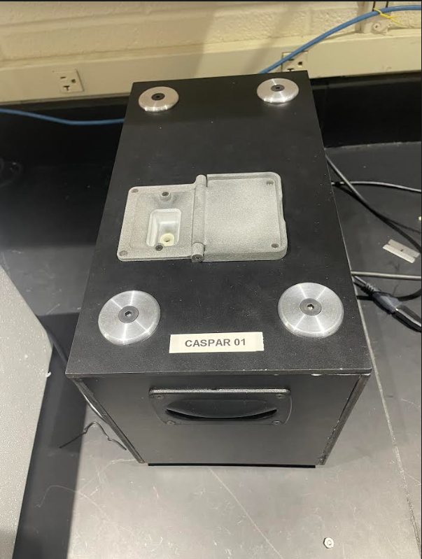

‘C-based Analysis of Samples by PCR with Adaptive Routine’

Version 1
Document Created by Kunal Chugh on 8/19/2022
Last Updated: 9/21/2022
Table of Contents
Overview 4
Quick Start 5
Parts of the ‘CASPAR’ Box 7
Tour of the Software 9
Overview 9
Tab 1: Main 9
Tab 2: Run Summary 11
Tab 3: Configurations 12
Running the Device 14
Overview 14
Electrical and Communication Connections 14

Overview
This document describes the use of both the ‘CASPAR’ Adaptive PCR Hardware and Software. The main software and server files are located on the Raspberry Pi inside of the instrument. The computer mainly contains functionality to access and use the User Interface. Typically, it can be launched from a Desktop shortcut(s). The black box that contains the control electronics, heater, and fluorimeter, is called the “CASPAR Box.” See Figure 1. The CASPAR Box with the open tube compartment is on the left, and the laptop running the software on the right.

[Insert Setup Image Here]

Figure 1: The laptop running the software is on the right and the CASPAR Box is on the left.

Quick Start
- Turn on the laptop and the CASPAR Box. Ensure you are connected to the Wi-Fi Network CASPAR-01. Go to the webpage by clicking on the Desktop shortcut(s).
  - If there is good communication between the instrument and the laptop, the Server Status button near the top right of the Webpage should show “Connected”.
- Using either the Configuration Dropdown or manual entry, ensure that the Project Name, Operator Name, and Total Cycles are filled in with the desired values. Other entry fields (such as RT, Experiment Name, Comments, Email, etc.) are optional, but can be filled in if desired.
- Click on the “Start PCR” button. In the popup, verify that you want to run the PCR with the indicated settings. Once started, the “System Status” indicator on the bottom of the screen should display “Running”, “PCR Running”, or “RT Running”.
  - While running, you are free to close out the webpage or leave it be. If you choose to close the webpage, data will repopulate on the screen once you go back onto the webpage.
  - If you entered an Email before the run begins, you will receive a notification once the run is complete.
- In the Main Tab, When the “System Status” indicator on the bottom of the screen displays “PCR Running”, the “PCR vs Cycle” plot should update after each cycle. The maximum possible reading is 2500, if the true value goes over that number, PCR graph readings will plateau at 2500.

- “Stop PCR” will stop the current run and save the data for troubleshooting or for analysis of the run that amplifies earlier than expected. The software stays running, and a new tube can be put in and tested.
- Data is auto saved and can be accessed in multiple ways after run completion. You can either Email the data to yourself or Download the data. Emailing and downloading the data can be found in the “Run Summary” Tab. Please ensure you take the necessary steps to download the data.
- Once the run is completed, you can either load another sample or close the software by first clicking on “Shutdown Server” and then turning off the PCR using the power switch.

Parts of the ‘CASPAR’ Box

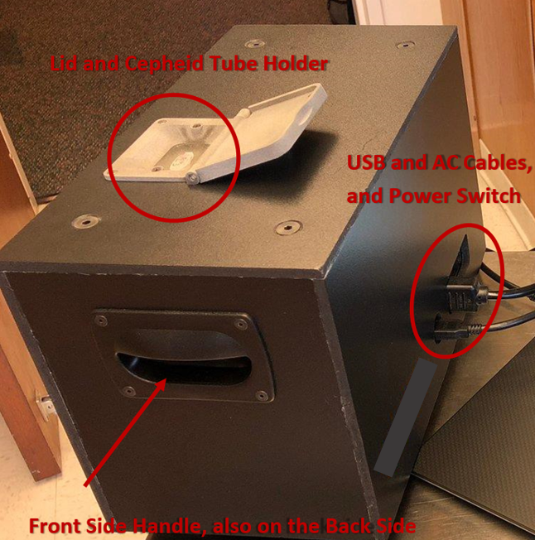
Figure 2: Features of the CASPAR Box, including the tube holder compartment, the USB and AC power connections, the power switch, and the handles.
The CASPAR Box with the cover on is shown in Figure 2. In Figure 2, the PCR (Cepheid) tube compartment, the front handle, the power switch, and the USB and AC power connections are labeled. To carry the CASPAR Box, use the handles. The cover has a ¾” gap in the front and back for proper air flow for cooling. It is necessary that the area around the bottom of the cover remain clear and is not placed next to a source of hot or cold air. Doing so will affect the PCR Cycle time during the PCR run.

Note: The CASPAR Box does NOT use the USB cable shown. No cables will be/should be placed into the USB input.

The CASPAR Box without the cover on is shown in Figure 3. In normal use, there is no reason to remove the cover.
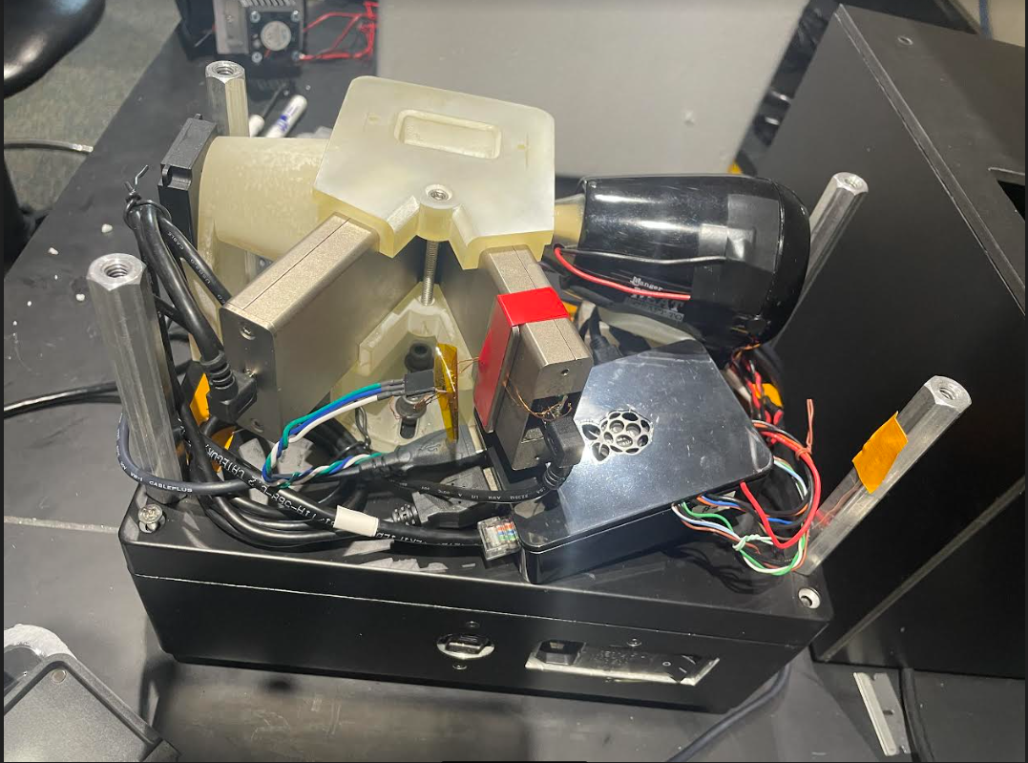
Figure 3: CASPAR Box without the cover. The Box cooling fan, the two Qiagen ESELogs, the heater, and the thermocouple wires are visible. Inside the bottom are the electronics, including the 5V DC and 120V AC power sources.

Tour of the Software

Overview
The main software and server files are located on the Raspberry Pi inside of the instrument. The computer mainly contains functionality to access and use the User Interface. To do so, first ensure the computer is connected to the Wi-Fi network CASPAR-01. Click on the Desktop Shortcut(s) to access the user interface. Clicking on the shortcut should bring the user to the webpage, called CASPAR, to run the PCR.
The software and user interface provided has many useful features. These features include real-time cycling and PCR display, data repopulation upon reopen, downloading run data, sending run data through email, creating configurations for a custom RT-PCR run, etc. These features all ensure that the user can smoothly conduct a PCR run. Once the run is completed, you can either load another sample or close the software and turn off the PCR using the power switch. If the UI is ever not displaying correctly, ensure that the webpage is in full screen.
On the top-right side of the webpage, there is a Shutdown Server button. This button should NEVER BE PRESSED during the PCR run unless there is truly an emergency and no other way to communicate with the instrument. It is only to be used when you must completely turn off PCR instrument -- either because you want to stop using the machine, a complication has arisen, or because the STOP PCR button is not working.

Tab 1: Main
On the webpage, which can be accessed through the Desktop Shortcut, the first tab, Main, will be shown (Figure 4). For general running of PCR tests, this is all that you need to operate the machine. Other tabs give more expert functions such as configuring, viewing, and sending data. The main feature on this tab is the graph PCR Output that shows the fluorescent value of up to 3 PCR channels after each heat-cool cycle.
If the program is running correctly (website connected to the server), the server status in the top bar should show “Connected” (shown in blue in Figure 4). Before filling out entry fields and starting the PCR, ensure that the server status shows that it is connected.
There are four required entry fields that must be filled in before the run begins. These include the Project Name (1), Operator Name (2), Configuration Selection (4), and Total Cycles (6). Specifically, Configuration Selection (3) is a pulldown menu that updates entry fields in the user interface with pre-made user configuration and setup information. These configurations can be made in the Configuration Tab (Tab 3).
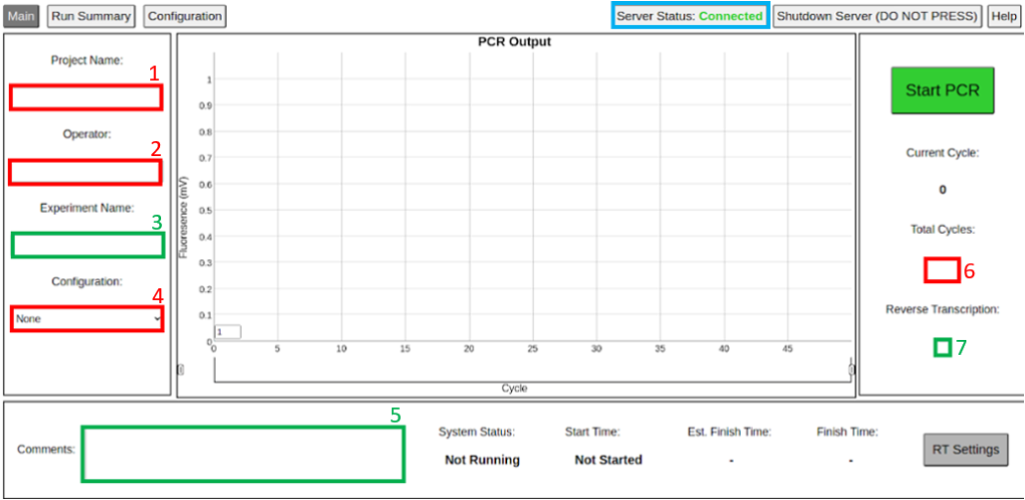
Figure 4: Main Tab of the CASPAR Box User Interface. Entry fields with a red box are entry fields that must be filled out before the run begins. Entry fields with a green box are optional entry fields.
After filling in all required entry fields, you will be able to start the PCR, using the green Start PCR button on the top right side of the screen. Once started, the button will change to a red “Stop PCR” button. This button will stop the test and save all the data -- useful if something is wrong with the test, or if you have enough cycles for the test results and want to quit it before the Total Cycles is reached.
At the bottom of the screen, you will find valuable information such as System Status, Start Time, Estimated Finish Time, and Finish Time. System Status will display if the system is running, if RT is running, if PCR is running, or if the system is not running. The Start Time gives the time when the test was started, and the Est. Finish Time gives the time estimate for the PCR test to finish based on the Total Cycles. This time is updated every heat-cool cycle, after the 3rd PCR cycle, as the actual cycle time is measured.

Tab 2: Run Summary
The second tab is the Run Summary tab (Figure 5). The features of this tab are sending and downloading data, error status updates, and the graph Cycling Information. The graph shows feedback from the heating and cooling system. This can be useful for diagnostics and knowing that the machine is functioning properly.
On the left side of the tab, there is a section for Experiment Info (Figure 5). It shows all relevant experiment information, such as the system status, errors, configuration name, project name, etc. On the right side of the tab, there is a section for the Error Status. This section displays all errors that occurred while running the system. If there are any major errors, please make a note of it, do some troubleshooting, and inform the Vanderbilt University developers.
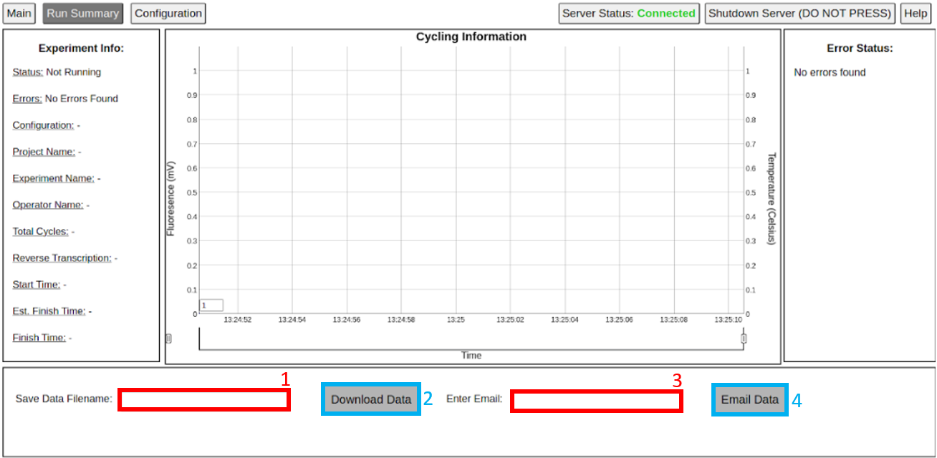
Figure 5: Run Summary Tab of the CASPAR Box User Interface. Entry fields are shown with a red box. Buttons are shown with a blue box.
The bottom of the tab has two entry fields and two buttons (shown in Figure 5). The Save Data Filename (1) entry field sets the filename for all the data for the PCR run. This name can only be changed BEFORE the run begins. If this is left blank, the system will automatically assign a save data filename, based on the project name and the current time and date. The Enter Email (3) entry field is the email that the data is sent to when the user presses the Email Data (4) button. Furthermore, a run finish message is also sent to the provided email when the PCR finishes its run. For ease, the Enter Email entry field can have a default email, which can be set in the Configuration tab. The Email Data (4) button and the Download Data (2) button are both ways the user can get data from the run when the run is completed.

Tab 3: Configurations
The third tab is the Configuration tab (Figure 6). The features of this tab include viewing the currently selected configuration, making a new configuration, deleting configurations, and accessing more advanced settings through the Developer mode. The tab is split into two main sections. Configuration Information on the left and Create Configuration on the right.
The Configuration Information section on the left side (Figure 6) shows the user the data and configuration details for the currently selected configuration. This includes the configurations name, default operator name, default email, default project name, total cycles, etc. The Delete Configuration button on this side can be used to delete the configuration whose information is currently being shown.
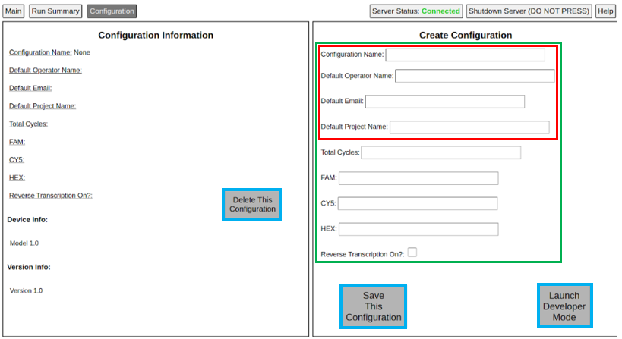
Figure 6: Configuration Tab of the CASPAR Box User Interface. Buttons are shown with a blue box. Required entry fields are shown in red, while optional entry fields are shown in green.
The Create Configuration section, which is on the right side, allows the user to save the many controls and settings needed to perform the PCR cycling to a text file, and later to recall that text file and those settings when a certain PCR test is to be run. In figure 6, the entry fields boxed in red are mandatory entry fields. Configuration Name, along with at least on of either Default Operator Name, Default Email, or Default Project Name must be filled out to create a configuration. Entry fields boxed in green are optional, but still useful, entry fields to help make the process of running the PCR faster and more efficient. On this side, there is a button to Save Configuration and Launch Developer Mode, which allows the user to customize advanced settings to run the PCR.

Running the Device

Overview
The main software and server files are located on the Raspberry Pi inside of the instrument. The computer mainly contains functionality to access and use the User Interface. To do so, first ensure the computer is connected to the Wi-Fi network CASPAR-01. Click on the Desktop Shortcut(s) to access the user interface. Clicking on the shortcut should bring the user to the webpage, called CASPAR, to run the PCR. If the UI is ever not displaying correctly, ensure that the webpage is in full screen.

Electrical and Communication Connections
The CASPAR Box has ONE main connection that needs to be made. An AC power cord must be connected to the box (shown in Figure 7). Furthermore, the power switch, which is next to the power cord, must also be turned on. Both are located on the side of the CASPAR Box. See Figure 7.
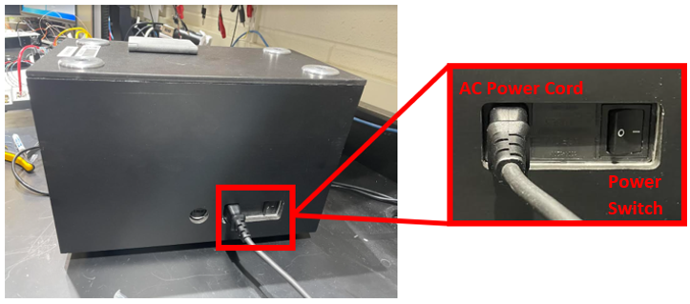
Figure 7: The AC power cord and the AC power switch on the side of the CASPAR Box.
Note: The CASPAR Box does NOT use the USB cable. No cables will be/should be placed into the USB input.
The instrument communicates with the computer by sending out its own Wi-Fi signal. It should be ensured that the computer connects to this Wi-Fi channel (named CASPAR-01) before the run is started. Do not connect to any other Wi-Fi Network. To ensure that the box is properly connected to the server and the instrument, the Server Status button near the top right of the Webpage should show “Connected”. If it does not, please troubleshoot. Check if the AC cable for the instrument is connected, if the power switch is on the ON setting, if the computer is connected to the instrument’s Wi-Fi network.

